**Lashing…**

**Square Lashing**

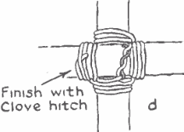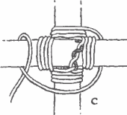Used to fasten two spars or poles together.

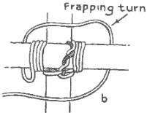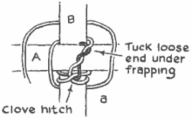

1. Start by crossing the two sticks or dowels at perpendicular or 90 degree angles.
2. Make a Clove Hitch on the vertical stick or dowel near the point where the two sticks cross. This fastens the rope to the stick.
3. Weave the rope under and over the crossed sticks alternately.[BSA Troop 780 Home Page](http://www.bsatroop780.org/) To do this, run the rope over the horizontal bar, around behind the vertical bar, then back over the face of the horizontal bar on the left. Tighten snugly, then bring the rope behind the vertical bar and up the right front side of the horizontal bar. Repeat this three or four times, keeping the rope tight.
4. When you have finished weaving the lashing, then frap it by wrapping the rope between the poles (in front of the back stick and in back of the front stick), pulling tightly. This tightens the connected poles.
5. Finish your lashing with another Clove Hitch

**Round Lashing**

Used to lash two poles together (i.e. constructing a flagpole)

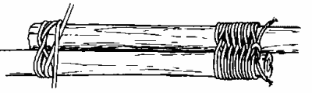

1. Tie a clove hitch round the bottom pole.
2. Wind the rope around both six or seven times.
3. Finish with two half hitches round both poles.
4. 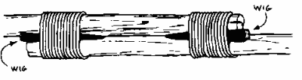The lashing can be tightened by driving a small wooden peg between the poles.
5. If possible force a wedge under the lashings to make them really tight. If the spars are vertical, bang the wedge in downwards.